3D Scene Proposal for Final Project
Edwin Martinez
1/15/26
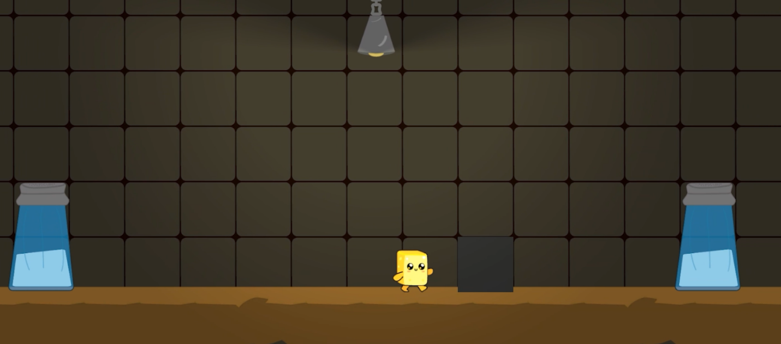
Selected 2D Scene
For my final project, I plan to recreate a 2D side-scrolling game scene (from my game, A Butter Life) in 3D using OpenGL. The selected image is a freeze frame environment that includes a ground surface, a tiled background wall, a player character and environmental props such as a lamp and containers. This scene is well suited for translation into 3D because it is visually clear, composed of distinct objects, and designed around simple geometric forms.
I selected this image because it is directly related to game development and allows for a controlled scope while still being visually interesting. The side-scroller perspective also makes it easier to maintain a consistent camera view while demonstrating depth, lighting, and object placement in a 3D space.
Objects to Be Replicated in 3D
The primary objects that will be replicated in 3D include:
- Ground platform
- Background wall tiles
- Player character
- Grey block object
- Lamp
- Saltshakers
These objects are a good choice because they represent common elements found in 2D game environments and can be constructed using basic 3D shapes easily. The player character will serve as the complex object, as it can be built from multiple primitive shapes combined together. Together, these objects create a complete and recognizable scene that can be expanded later with textures, lighting, and camera controls.
Basic 3D Shapes Used
A variety of basic 3D shapes will be used to construct the scene:
- Plane: A plane will be used to represent the background wall of the scene which are tiles.
- Box: Boxes will be used for the ground platform, the crate object and the main body of the player character.
- Cylinder: Cylinders will be used for environmental props such as the main body of the saltshakers. Also, the limbs of the player character.
- Cone: A cone will be used to represent the lamp housing.
- Sphere: Spheres can be used for smaller rounded components of the player character, such as eyes. A sphere can also be used for the light bulb for the lamp.
The player character will be composed of multiple shapes, such as a box for the body, spheres for facial features and cylinder for limbs making it our complex shape.
Scope and Feasibility
The scene can be developed incrementally, starting with simple geometry and positioning, then enhanced with textures and lighting. The side-scrolling layout keeps the scene compact and focused while still allowing depth and spatial relationships to be demonstrated in 3D. The scene is simple yet rich enough to demonstrate core OpenGL concepts such as object composition, transformations and texturing making it both achievable within the scope of the project and engaging to build upon for future assignments.

